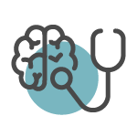
Understanding Substance Use, Abuse and Addiction Recommended Resources
https://www.samhsa.gov/ excellent resource. Check tab labeled Substance Use

https://www.onechoiceprevention.org/ excellent resource regarding substance abuse prevention

https://www.samhsa.gov/about/offices-centers/csap Federal Substance abuse prevention center

https://nida.nih.gov/ NIH agency focused on drug abuse research

https://www.niaaa.nih.gov/ NIH agency focused on alcohol abuse and alcoholism

https://www.who.int/teams/mental-health-and-substance-use/overviewn WHO SUD resources

